Sql > Structured Query Language

It’s a language used by RDBMS (Sql Server, MySql , Oracle)

Statements in SQL is of following types

DDL > Data Definition Language > create , alter , drop , truncate table

DML > Data Manipulation Language > insert , delete , update , select

DQL > Data Query Language > select

DCL > Data Control Language > grant , revoke

TCL > Transaction Control Language > commit , rollback

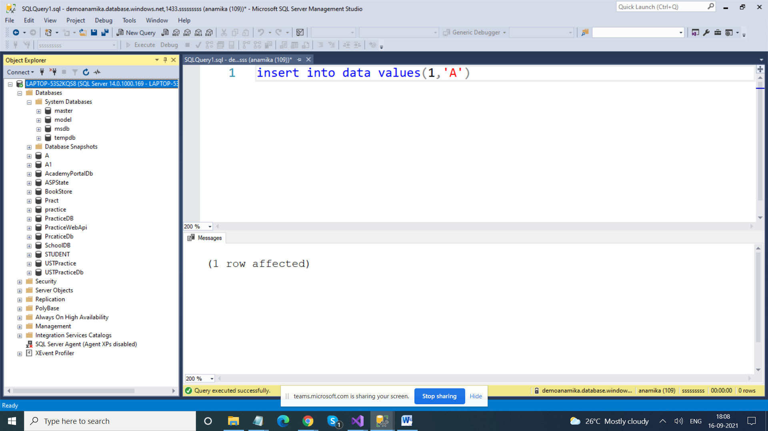

Constraints > Are used to provide validation rules / put restriction on what values can be entered in the columns

1. Primary Key > It is used to uniquely identify records in table ( 1. Not Null 2. Unique) ( A table can have only 1 PK)
2. Foreign Key (It is used to connect two tables , It’s a key whose value is dependent on value of PK of some other table)
3. Unique > No duplicacy , Yes it can null (only 1)
4. Not Null > Nulls are not allowed
5. Check (used to provide some range)
6. Default > used to provide some default value if we do not give any value to that column

create database tempdatabase

use tempdatabase

DDL

create table employee (

id int,

name varchar(20),

address varchar(30),

salary int)

DML

insert into employee(id, name , address, salary) values

(1,'Ajay','Delhi',19000),

(1,'Ajay','Delhi',19000),

(1,'Ajay','Delhi',19000),

(1,'Ajay','Delhi',19000),

(1,'Ajay','Delhi',19000)

--DQL

select \* from employee

DDL

drop table employee

create table employee (

id int primary key,

name varchar(20) not null,

address varchar(30) check(len(address) > 20),

salary int not null check (salary between 20000 AND 30000))

insert into employee(id, name , address, salary) values

(1,'Ajay','8 block, Ramesh Nagar , New Delhi',29000)

insert into employee(id, name , address, salary) values

(2,'Ajay','8 block, Ramesh Nagar',23000)

insert into employee(id, name , address, salary) values

(3,'Deepak','9 block, Ramesh Nagar , New Delhi',21000),

(4,'Ajay','9 block, Ramesh Nagar , Old Delhi',23000),

(5,'Ajay','9 block, Ramesh Nagar , Calcutta',27000)

select \* from employee

alter table employee alter column address varchar(50)

Select \* from employee where address LIKE '%Delhi%'

Select \* from employee where address LIKE '9%'

Select \* from employee where address LIKE '%Delhi'

Select \* from employee where salary between 21000 AND 26000

select id, name from employee

update employee set salary = salary + 1000

update employee set address ='8 block, Lines Road, C Line, Calcutta' where name ='Deepak'

delete from employee where id between 1 and 3

insert into employee (id, name , salary)

values(7,'Lalit',21000)

select \* from employee

insert into employee values (8,'Jatin', null, 23000)

select \* from employee where address is not null

select \* from employee where address is null

alter table employee add manager varchar(20)

update employee set manager = 'Lalit' where id between 1 and 4

update employee set manager = 'Sagar' where id > 4

alter table employee drop column salary